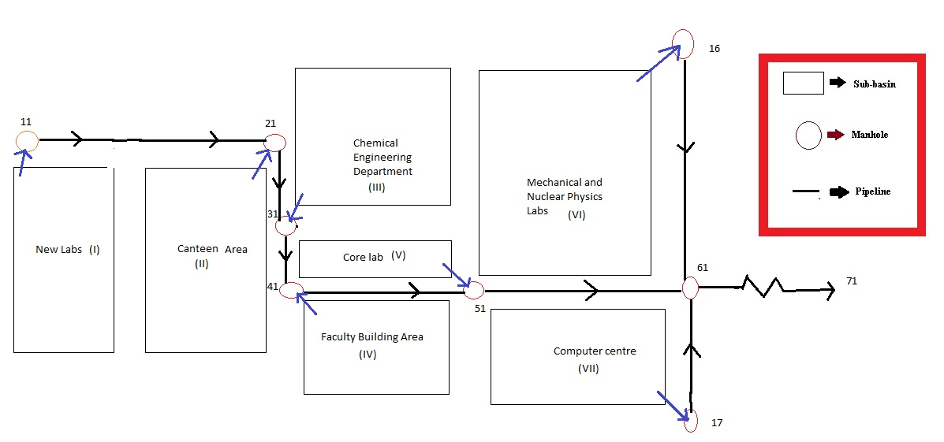

- The excel file given in the folder contains hourly rainfall data for 50 years. Try to fit Log-Normal and Gumbel’s distribution to the data. Use the best-fit distribution for estimating the frequencies. Plot the intensity duration frequency curves corresponding to 2, 5, 10, 15, 30 and 50 years of return periods, respectively. Once the IDF data are obtained, fit equation of the form: $i_{D, T}=\frac{K*T^{x}}{{\left(D+a\right)}^{n}}$ where, D is the duration of the storm in minutes and T is the return period of the storm event in years.
- Design the storm water drainage system for 5 years return period. Provide uniform triangular gutter section with curb opening inlet. Assume single lane service road with longitudinal slope of 0.001 and cross slope of 0.025. Use the Rational formula for calculating the peak discharge and Kerby's equation for the time of concentration. Also, assume no by-pass flow while designing the inlets.
- Using statistical method, compute the probable maximum 12-h precipitation with a return period of 100 years.
- Develop the hyetograph for a 1.5-hour storm of 25-year return period using alternating block method with 15-time intervals.
- Check the adequacy of your design for the storm event in (d). If your design is inadequate, estimate the extent of water logging in the vicinity.

Basin | Area of the basin  (Hectares) | Division of the basin area (%) |  | Drainage Length  (m) | Slope of the basin | Kerby’s coefficient
I | 0.5 | Residential | 58 | 62.2 | 0.009 | 0.03
I | 0.5 | Lawn and open space | 32 | 62.2 | 0.009 | 0.03
I | 0.5 | Paved street roads | 10 | 62.2 | 0.009 | 0.03
II | 0.45 | Residential | 65 | 48.3 | 0.012 | 0.025
II | 0.45 | Lawn and open space | 25 | 48.3 | 0.012 | 0.025
II | 0.45 | Paved street roads | 10 | 48.3 | 0.012 | 0.025
III | 0.57 | Residential | 60 | 60.2 | 0.015 | 0.031
III | 0.57 | Lawn and open space | 30 | 60.2 | 0.015 | 0.031
III | 0.57 | Paved street roads | 10 | 60.2 | 0.015 | 0.031
IV | 0.42 | Residential | 65 | 45.6 | 0.013 | 0.023
IV | 0.42 | Lawn and open space | 28 | 45.6 | 0.013 | 0.023
IV | 0.42 | Paved street roads | 7 | 45.6 | 0.013 | 0.023
V | 0.2 | Residential | 60 | 32.7 | 0.009 | 0.020
V | 0.2 | Lawn and open space | 36 | 32.7 | 0.009 | 0.020
V | 0.2 | Paved street roads | 4 | 32.7 | 0.009 | 0.020
VI | 0.5 | Residential | 56 | 59.8 | 0.016 | 0.032
VI | 0.5 | Lawn and open space | 24 | 59.8 | 0.016 | 0.032
VI | 0.5 | Paved street roads | 20 | 59.8 | 0.016 | 0.032
VII | 0.38 | Residential | 58 | 49.1 | 0.012 | 0.027
VII | 0.38 | Lawn and open space | 32 | 49.1 | 0.012 | 0.027
VII | 0.38 | Paved street roads | 10 | 49.1 | 0.012 | 0.027

Pipeline | Length of the pipeline (m) | Avg. slope
11-21 | 1000 | 0.003
21-31 | 400 | 0.0042
31-41 | 400 | 0.0035
41-51 | 500 | 0.002
51-61 | 600 | 0.0025
16-61 | 700 | 0.003
17-61 | 300 | 0.004

Manhole | Reduced level of manhole (m)
11 | 140.1
21 | 139.3
31 | 138.5
41 | 137.6
51 | 136.4
61 | 132.5
16 | 135.2
17 | 134.6

Note:- You can make any other assumption(s), if necessary, beyond the code provisions. Make sure to mention the same in the final report.

